**Project Design Phase-II Technology Stack (Architecture & Stack)**

|  |  |
| --- | --- |
| Date | 14 October 2022 |
| Team ID | PNT2022TMID26330 |
| Project Name | Project – IOT ENABLED SMART FARMING APPLICATION SYSTEM |
| Maximum Marks | 4 Marks |

**Technical Architecture:**

The Deliverable shall include the architectural diagram as below and the information as per the table1 & table 2

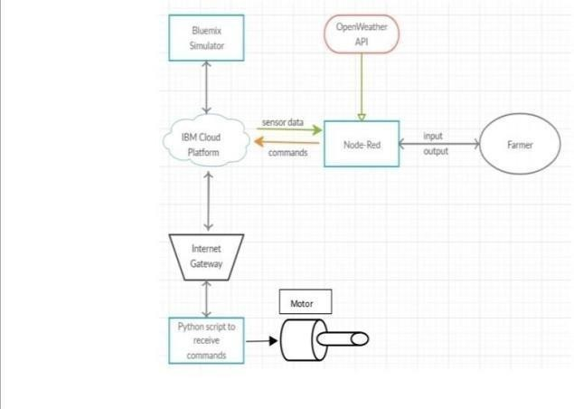

Guidelines:

1. Include all the processes

Technology Block)

(As an application logic /

1. Provide infrastructural demarcation (Local / Cloud)
2. Indicate external interfaces (third party API’s etc.)
3. Indicate Data Storage components / services
4. Indicate interface to machine learning models (if applicable)

* *The different soil parameters temperature, soil moistures and then humidity are sensed using different sensors and obtained value is stored in the ibm cloud.*
* *Aurdino UNO is used as a processing Unit that process the data obtained from the sensors and whether data from the weather API.*
* *NODE-RED is used as a programming tool to write the hardware, software and APIs. The MQTT protocol is followed for the communication.*
* *All the collected data are provided to the user through a mobile application that was developed using the MIT app inventor. The user could make a decision through an app, weather to water the crop or not depending upon the sensor values. By using the app they can remotely operateto the motor switch.*

**Table-1 : Components & Technologies:**

|  |  |  |  |
| --- | --- | --- | --- |
| **S.No** | **Component** | **Description** | **Technology** |
| 1. | User Interface | How user interacts with application e.g. Web UI, Mobile App. | HTML, CSS, JavaScript / Angular Js / React Js etc. |
| 2. | Application Logic-1 | Logic for a process in the application | Python |
| 3. | Application Logic-2 | Logic for a process in the application | IBM Watson IOT service |
| 4. | Application Logic-3 | Logic for a process in the application | IBM Watson Assistant |
| 5. | Database | Data Type, Configurations etc. | MySQL, NoSQL, etc. |
| 6. | Cloud Database | Database Service on Cloud | IBM Cloud |
| 7. | File Storage | File storage requirements | IBM Block Storage or Other Storage  Service or Local Filesystem |
| 8. | External API-1 | Purpose of External API used in the application | IBM Weather API, etc. |
|  |  |  |  |
| 9. | Machine Learning Model | Purpose of Machine Learning Model | Object Recognition Model, etc. |
| 10. | Infrastructure (Server / Cloud) | Application Deployment on Local System / Cloud Local Server Configuration:  Cloud Server Configuration : | Local, Cloud Foundry, Kubernetes, etc. |

**Table-2: Application Characteristics:**

|  |  |  |  |
| --- | --- | --- | --- |
| **S.No** | **Characteristics** | **Description** | **Technology** |
| 1. | Open-Source Frameworks | List the open-source frameworks used | Technology of Opensource framework |
| 2. | Security Implementations | Sensitive and private data must be protected from their production until the decision-making and storage stages. | e.g. Node-Red, Open weather App API, MIT App Inventor , etc |
| 3. | Scalable Architecture | scalability is a major concern for IoT platforms. It has been shown that different architectural choices of IoT platforms affect system scalability and that automatic real time decision-making is feasible in an environment composed of dozens of thousand. | Technology used |
| **S.No** | **Characteristics** | **Description** | **Technology** |
| 4. | Availability | Automatic adjustment of farming equipment made possible by linking information like crops/weather and equipment to auto-adjust temperature, humidity, etc. | Technology used |
| 5. | Performance | The idea of implementing integrated sensors with  sensing soil and environmental or ambient parameters in farming will be more efficient for overall monitoring. | Technology used |